Tucker, Albert (1914 – 1999)

Albert Tucker was a modern Australian painter, known best for his series of works depicting the horrors of wartime and harsh images of the Australian landscape. Tucker was an artist of seemingly irreconcilable contrasts – a social conservative who in his youth flirted with the Communist Party. He was a master draughtsman and charming illustrator, yet produced challenging works that are, to many viewers, dense and unfathomable. A child of the depression, he knew hardship, yet clung firmly to his middle-class values and a fierce determination to succeed financially. With an often-forbidding public persona, he was also known as a man of great charm and personal warmth. Largely self-educated, he worked first as a commercial artist, illustrator and cartoonist, before falling in with young modernist contemporaries Sidney Nolan and Arthur Boyd and the ‘Heide’ circle surrounding John and Sunday Reed. An artist of uncompromising determination, he was to gain the reputation and financial reward he always saw as his due. As the myth surrounding the world of Heide and the Angry Penguins continues to grow, so does Tucker’s place in Australian art, now firmly recognised in a permanent gallery in his name at the Heide Museum of Modern Art in Melbourne.

Tucker’s early work was informed by his experiences of the depression and the outbreak of war in 1939. After a short period of military service in 1942, he spent most of the war years developing a series of motifs that would challenge everything he had known of art to that point. His Images of Modern Evil series is an angry cry against the decline of human values in wartime and, while effectively unsaleable, they became the basis on which all his future art was built. Tucker left Australia in 1948 and travelled to London before settling in Paris. He painted and exhibited widely without making great headway, mainly because the uncompromising darkness of his imagery was out of step with a resurgent Europe rebuilding after the long years of war. The breakthrough came in 1956, in a joint exhibition with Sidney Nolan in Rome. Invigorated by Nolan’s bright images of the Australian outback, Tucker returned to his Australian roots. He created new works around the themes of bushrangers, explorers and mythical beings in a bush context. While Nolan had opted for a slick and glossy paint surface using the new medium PVA [Poly Vinyl Acetate], Tucker used the same material to bind sand, gravel, cardboard and other materials into a gritty three dimensional surface.

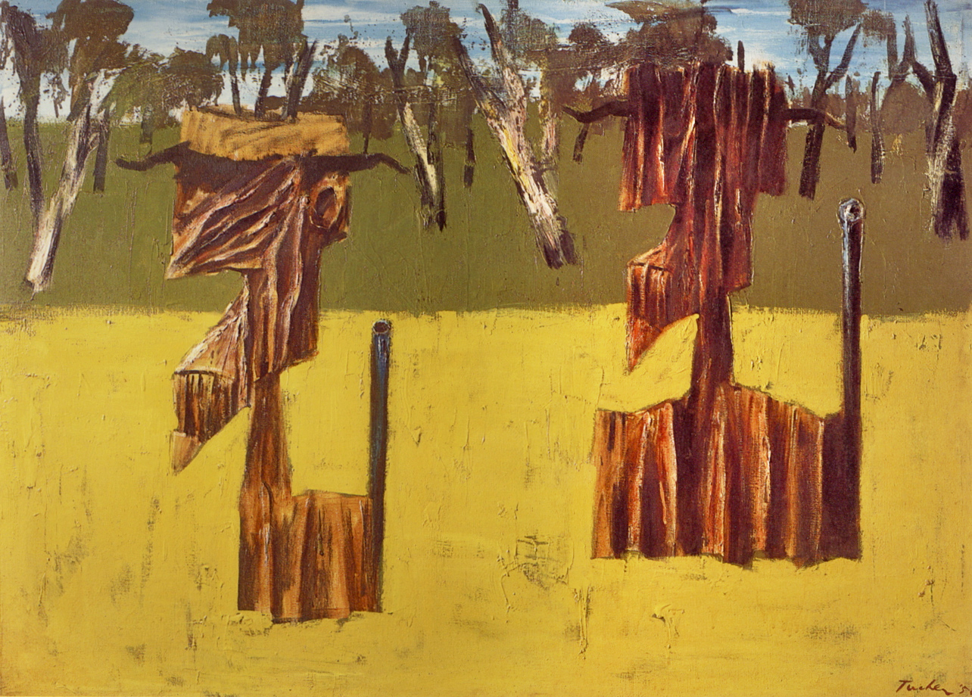

Albert Tucker, Explorers Fording the River, 1958, oil on canvas, 91.5 x 125.4 cm, Newcastle Art Gallery. Copyright to be sought from: Barbara Tucker, 3 Crestmont Crt, Toorak, VIC, Australia, 3142. Ph: +61 3 9822 7678.

Returning to Australia in 1960 Tucker settled in a bush retreat at Hurstbridge, just outside Melbourne. He depicted the trees and wildlife around him while developing a new iconography based on biblical and mythological stories. Fauns, explorers and craggy bushmen seem gouged directly from the land, indistinguishable from the earth they inhabit. His masked and helmeted figures are part man and part fissured rock; ancient heads carved from the stony landscape and a new sense of colour replaced the dominant black of earlier works. In his later years, Tucker painted a wide range of subjects, from mellow landscapes and bird studies to re-imaginings of his gritty wartime nightmares.

References and Further Reading

Fry, Gavin. (2006) Albert Tucker, Sydney: Beagle Press.

Mollison , James and Minchin, Jan. (1990) Albert Tucker: A Retrospective, Melbourne: National Gallery of Victoria.

